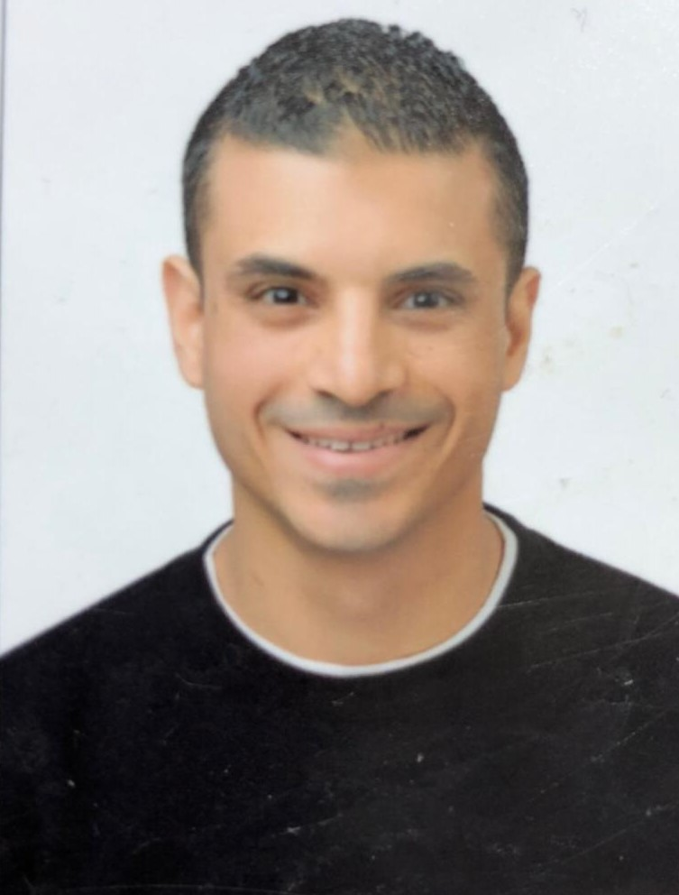

**Curriculum Vitae**

**Production Shift Leader Engineer**

* **Personal Profile**

**Name:** M**ohamed Abdul Elfattah Elsantawi.**

**Date of Birth: 23thOctober 1987.**

**Age: 35 years old.**

**Place of birth: KSA.**

**Nationality: Egyptian**.

**Address: Jordan, Egypt.**

**Cellular Phone: +962796028264 , +201009193767**

**Marital Status: Married.**

**Religion: Muslim.**

**E-Mail:**[**mohamedsant3@gmail.com**](mailto:mohamedsant3@gmail.com)

* **Objective**

**I am seeking new position that will fetch me a good career and shall promise to work in the best of my ability, highly ambitious and energetic person with a great drive to achieve success in whatever is undertaken.**

* **Career Statement**

**Well versed in chemical and process engineering, design, environmental system and energy conservation , willing to work as a process engineer with a view to utilize my professional skills.**

* **Experiences**
* **Working in the Production department at Arab Swiss Engineering Company (ASEC) for Cement Manufacture from 1/9/2012 in the listed sites:**
* **Sinai Grey Cement site.**
* **Misr Qena Cement site.**
* **Alminya Asec Cement site.**
* **Assuit BIMIC site.**
* **Jordan Qatrana Cement site.**
* ***Work as Senior Kiln Operator in Qatrana Cement Company in Jordan since 1/11/2015 till 1/8/2020.***
* ***Work as Shift Leader Engineer in Qatrana Cement Company in Jordan since 1/8/2020 till now.***
* **Diploma from AUC (American University in Cairo) in the production of the cement (Cement Industry Professional Diploma CIPD).**
* **Diploma in Cement manufacture from ASEC (ACMC: Asec Cement Manufacture Course).**
* **Major Accountabilities:**
* Deals with various production stages to produce cement.
* Work on SOP (Standard Operating Procedures) system with CCR Engineers.
* Comply with all the company’s safety and environmental requirements.
* Ensure all equipment and machines are operated at optimum Conditions to achieve the Planned KPIs.
* Daily Review with all shift employees the desired KPIs for each area.
* Good knowledge of the cement product's characteristics.
* Good knowledge of Quality control methods and instrument
* Worked on Cement tube mills & Vertical Raw Mill (Atox – Fuller) & Coal Mill & Rotary Kiln.
* Work on double string KHD (low NOx and pyrclone system-5stage each string-long dry kiln 69 m).
* Providing engineering support in plant operations.
* Take corrective action as necessary and report and recommend solutions for production problem areas.
* Assure the regular inspection and evaluation of all operating to help maintain production required.
* In-depth knowledge of computer applications with outstanding communication skills.

**Education & Qualifications**

**Degree Obtained*:* B.Sc. of Chemical Engineering,**

**Graduation Year: June-2010**

**Grade**: **GPA 2.56 Good**

**Port Said University.**

**High school**

**Experimental Language School 2005**

**Skills**

* **Web Developer**
* **Programming Language:**
* **C**
* **C++**
* **Data Structure**
* **Algorithm**
* **HTML**
* **CSS**
* **JavaScript**
* **JQuery**
* **SQL Database**
* **PHP**
* **OOP**
* **Git&Github**

***Desktop Applications***

* **MS Word**
* -Familiar with legal terminology and litigation documents.
* -Proficient in WordPerfect and MS Word.
* **MS Excel: *able to do some simple financial modeling and forecasting.***
* ***Outlook***
* **MS PowerPoint**
* -Excellent communication & organization skills.
* -Admirable experience in preparing PowerPoint presentations for clients.
* -Outstanding knowledge of Photoshop and web design.
* -Exceptional ability to format and edit slides for various note pages.
* -Amazing communication skills in both oral and written forms.
* -Excellent ability of self-correspondence.
* -Ability to work under pressure.
* -Decision making at strategic and operational levels.
* -Negotiation skills.

***Languages***

* **Arabic:** Mother Tongue.
* **English:**Fluent.